Cale Cormaney
Motivation Model and Reflection

Description of theory:
There are countless theories and ideas when it comes to motivating individuals to complete a task. The main theories that I used as inspiration for the creation of my own was the Goal theory and the Expectancy theory. Although these were the ones used in the example, I expanded my own and added some functions that I feel are necessary.
My theory revolves around the individual identifying one specific goal, this may be a desire or a need. No matter that this goal may be, it’s important that it is clearly identified and decided upon in order to begin the process of obtaining it. This type of theory correlates well with the goal setting of an athlete when it comes to working towards obtaining a want or need. After the specific goal is identified, it is then a necessity to discuss why this specific goal is necessary or desirable for the individual. By having these types of discussions, the individual can verbally express the foundation of the goal and reflect as to why they wish to accomplish this goal. The next step is to make sure that this goal is accepted by the individual. This concept correlates with the Expectancy theory as I agree it is important for the individual to be all in when it comes to being motivated. For example, the athlete in this scenario would have to be strongly on board in regard to the goal and willing to do whatever it takes to achieve it. After the goal is accepted, there then needs to be a construction of a plan. The individual must understand the various steps that are going to be took in order to achieve the goal, and they must be open and willing to complete these steps. As they begin this process, the next step focuses on the importance of the overall support shown to the individual as they endure the trials and tribulations when it comes to pursuing the goal. Being supportive and actively involved with their process is critical as it continuously motivates them to keep on going. However, the support is only beneficial if the individual is putting in the effort of their own! This in my opinion is the most crucial step, as no matter how much one is motivated, it ultimately on them if they are willing to do the work themselves. And finally, the final step is the achievement of the goal and the individual obtains what they were working towards.

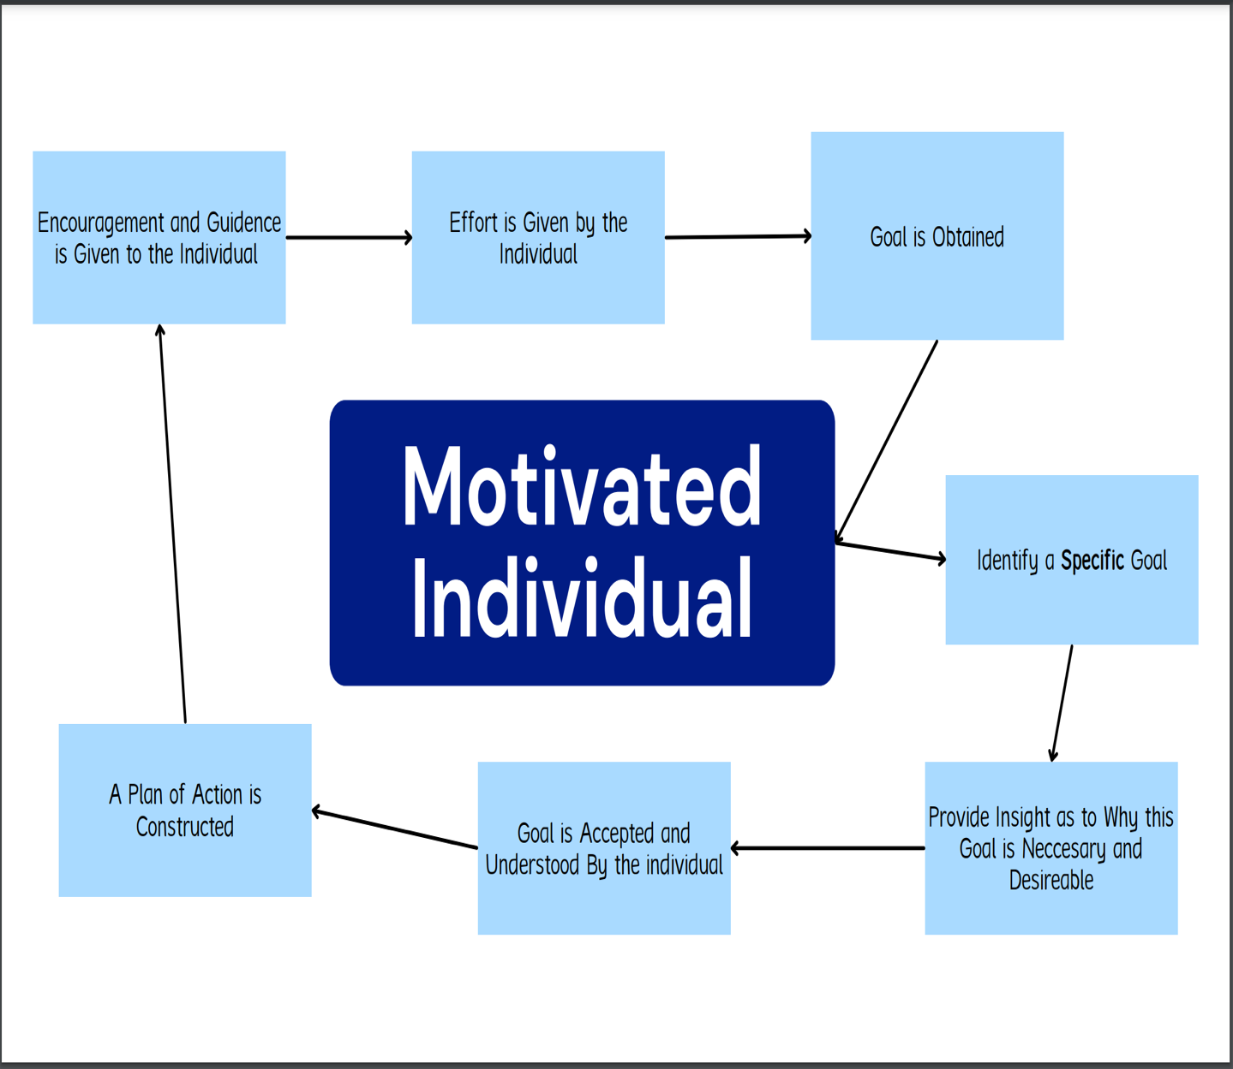

Effectiveness of Plan:
This theory was compiled based on the Goal and Expectancy theory as well as my personal experience when it comes to the motivation tactics I have seen as an athlete. As I was re-visiting the various theories this week, I attempted to use many of them throughout the practices of the week. It was by doing this that I created my very own theory based on what I believed was the most effective way to motivate an individual.
As a current captain of the Fort Hays Football team, it is part of my role to motivate my follow teammates both on and off the field. I have many examples throughout my time as captain where I have had to alter my motivation tactics to better meet the needs of the player of the specific scenario. This past week however, I had some interactions with a freshman from Dallas, Texas that was in need of motivation. Our interactions started due to his body language being off and me, confronting him about it. He told me that he was struggling because he was on our scout team and is not currently on our playing roster. After some discussion, I had him verbalize the specific goal he wanted to achieve, this was that he wanted to play. We then talked about why this was important to him, as he described his dreams of playing and wanting to test himself in our division. After some encouragement and clarification this individual accepted the goal and was willing to create a plan in order to move forward and achieve this desire. After practice on Tuesday, we again discussed this goal and this time I had him construct a plan. He said that he was going to do extra work after practice for the remainder of the season as well as putting in extra hours this off season in order to better his craft. The plan he was describing consisted of a lot of time and hard work, however he seemed very eager to start and passionate to achieve his set goal. The next day as well as Wednesday after practice I saw him begin his journey and he spent about an hour each day after practice working various foot work drills and he even ran some extra sprints. Upon seeing this, I stayed and did some work with him as while also encouraging him as much as I could. Ultimately, his willingness and desire is the piece that will carry him to success. Unfortunately, due to the extensiveness of his goal I will not be able to see if he accomplishes this until next season, however I plan on encouraging him and supporting him along the way!
Overall, I was very pleased with the effectiveness of my theory. Although this specific example is much more long-term and I do not have the results quite yet, I am very confident that this individual will be able to obtain his goal! As well, I believe that this theory can be applied anytime motivation is needed. These steps can break down any process and can be used as a blueprint to help others obtain their goals!

